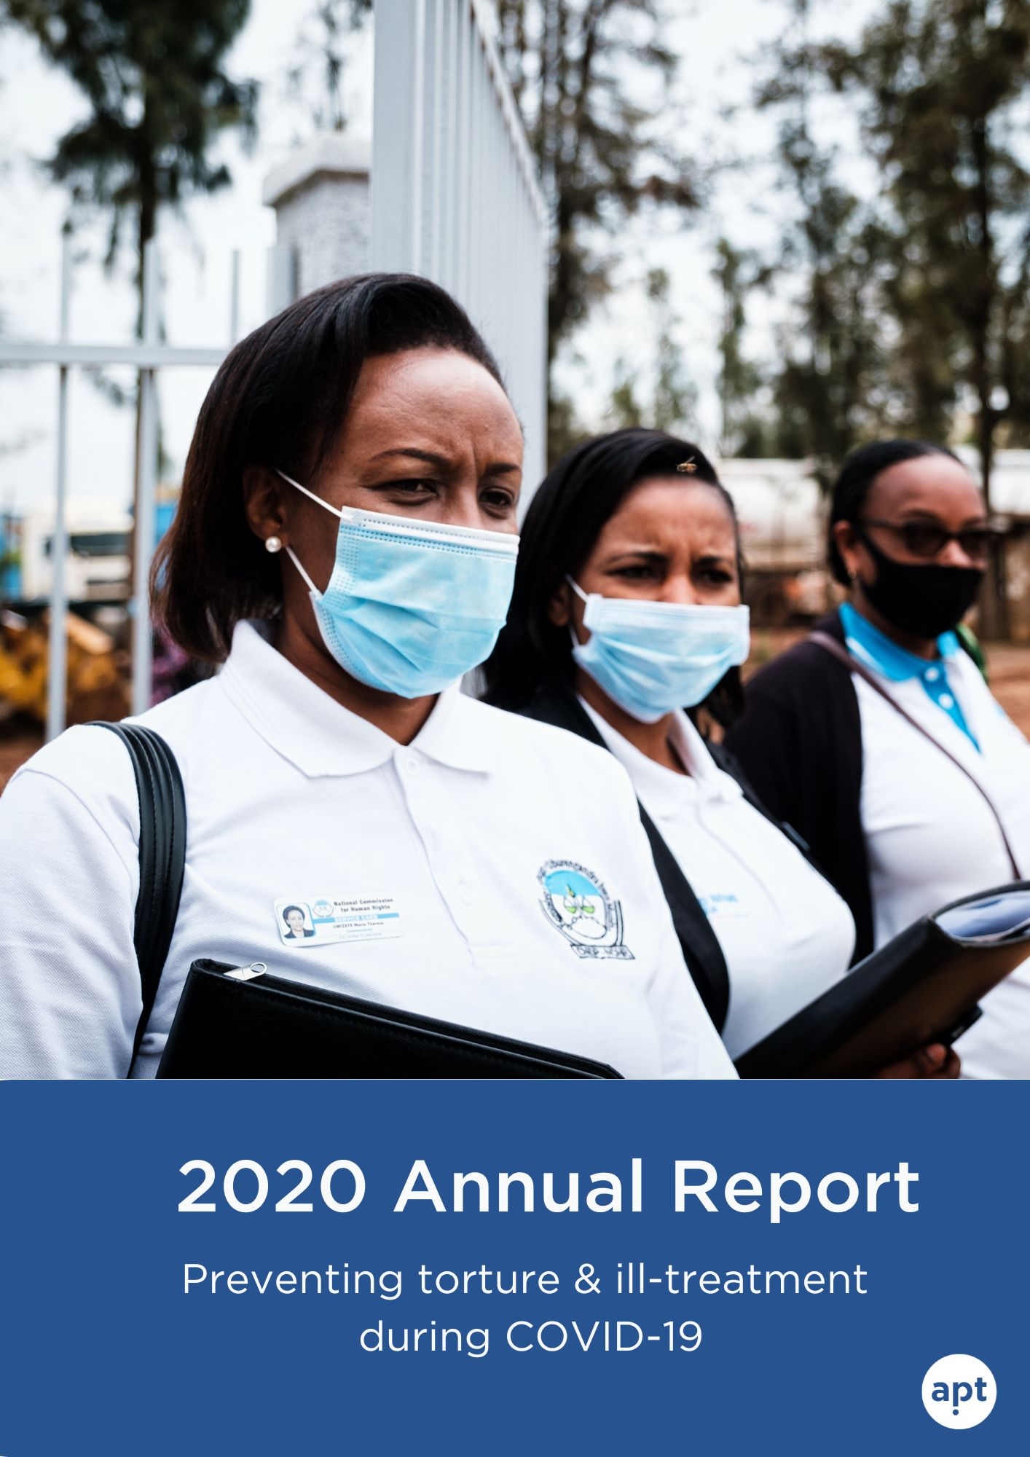

During COVID-19, our vision is as relevant as ever

2020 was a challenging year. The pandemic affected us all, with dramatic consequences for many.

COVID-19 highlighted structural issues and vulnerabilities in places of detention but also, in certain countries, on ill-treatment in the enforcement of lockdown and other restrictive measures. And the repressive responses to public demonstrations and civil movements in some parts of the world showed the continuing relevance of the APT’s vision for societies without torture and ill-treatment.

Our new Strategic Plan 2020-2023 responds to these risks by working for fair criminal justice systems, protection for persons in situation of vulnerabilities, strong oversight of detention and raising more voices against torture.

This annual report presents our work in 2020 to achieve changes in these areas, including:
- Our response to COVID-19: we supported national preventive mechanisms to work in new ways and developed data analysis on COVID and detention;
- Our focus on areas of risks of torture and ill-treatment: we worked with oversight bodies to monitor the first hours of detention and the situation of women in prisons
- Our organisational transformation: our smaller, agile team supports our partners with advice, online training and tools available on our new website.
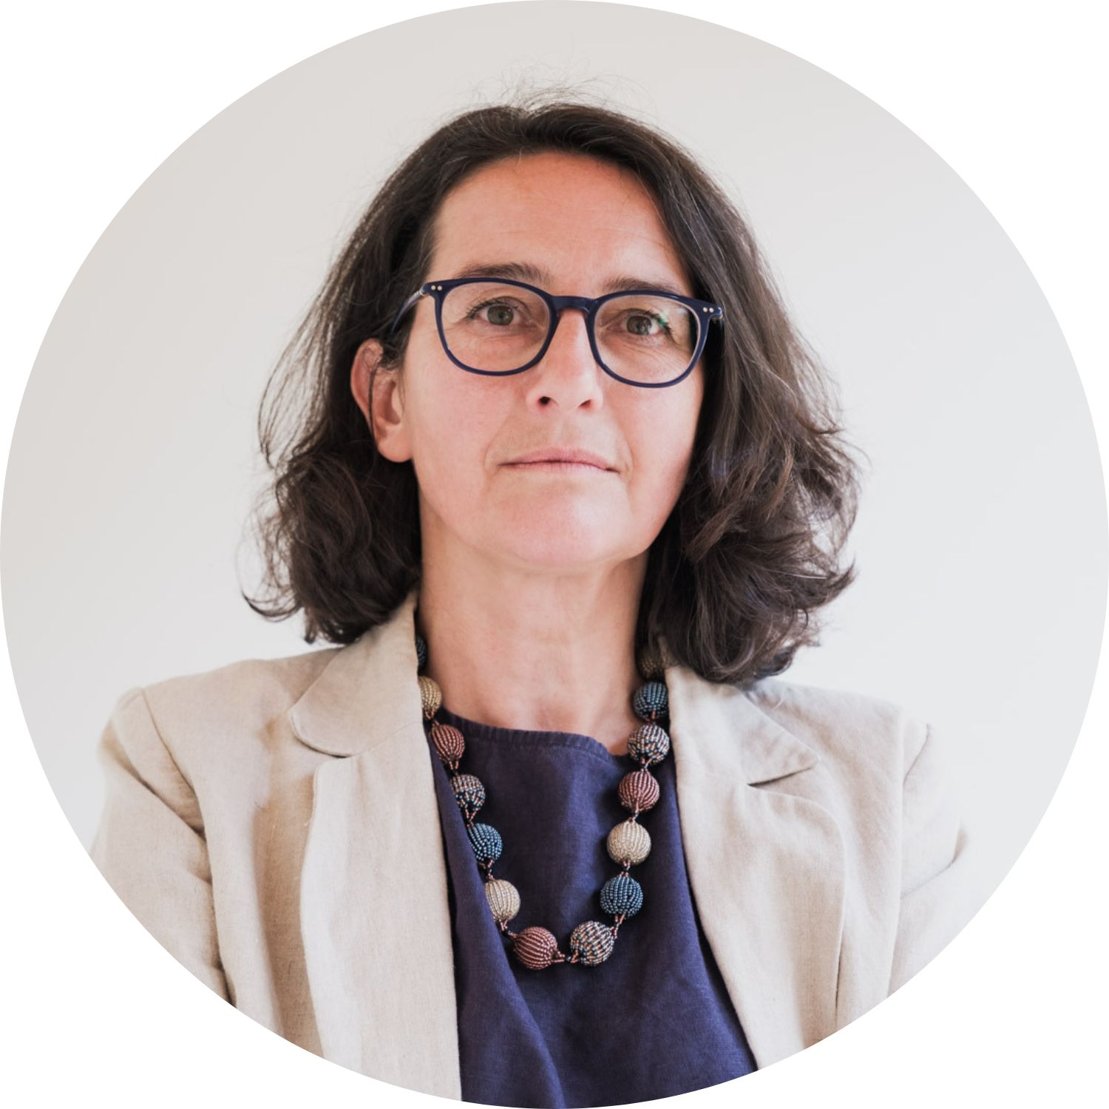
We thank our partners for their trust and cooperation.
Together, we can prevent torture.

Barbara Bernath
APT Secretary General

Transparency. Dignity. Agility.

These three values helped us reshape our approach in response to COVID-19, as Barbara Bernath explains in our end-of-year message to partners and supporters.

How we drive change

This year marked the start of new phase in the APT’s ongoing work to prevent torture and ill-treatment.

Our new Strategic Plan 2020-2023 builds on the expertise we have developed over the past 40 years. It draws on an analysis of the current global environment and on our understanding of how change happens.

Our goal is to build societies free from torture and ill-treatment. We focus on persons who are most at risk of being tortured, as well as those moments, practices or places where there are heightened risks.

We seek to drive change in four key areas: in criminal justice systems, for persons in situation of vulnerabilities, through new voices against torture and independent oversight of detention.

To achieve these changes, we work with a broad range of partners: oversight bodies, especially national preventive mechanisms, civil society, government, the judiciary, national human rights institutions and law enforcement.

While our operations focus on priority countries in Africa, Asia and Latin America, we have a global reach through digital engagement, online resources and communication initiatives delivered in our four working languages.

Our strong values and principles, as well as our emphasis on partnerships, agility and innovation, form the basis of our identity and guide our work.

Introducing our 2020-2023 Strategic Plan

Our video introduction explains the four areas where we will drive change.
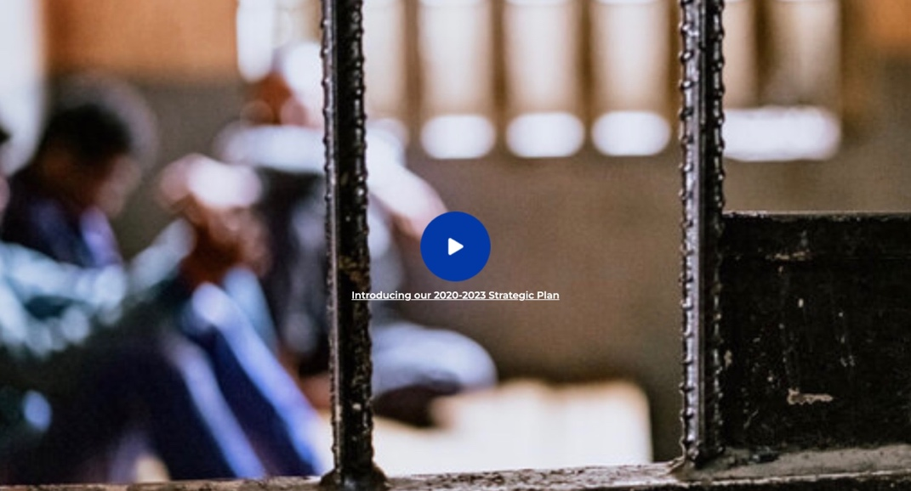

Contributing to fair criminal justice systems
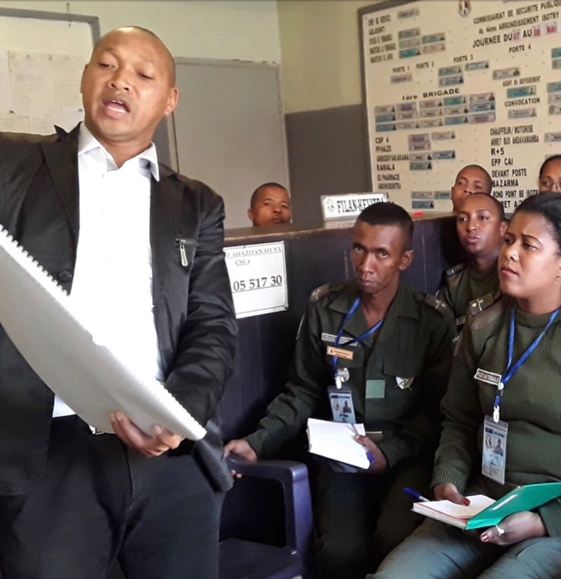
The first hours of custody is a time of heightened risk of torture and ill-treatment. We work to strengthen safeguards during this critical period and lower those risks, as well as promote effective interviewing by investigating authorities.

The death of George Floyd, excessive force against public demonstrations, and the harsh enforcement of lockdown measures in countries across the globe demonstrate the profound need for police reform.

This is also a focus of our Strategic Plan.

Our highlights in 2020
- International Principles on Effective Interviewing for Investigative Authorities are being finalised by the Steering Committee, facilitated by the APT.
- We provided ongoing support to our partners in Brazil, Madagascar and Thailand to strengthen the implementation of legal and procedural safeguards during the first hours of detention.
- We facilitated an exchange on monitoring implementation of safeguards with National Preventive Mechanisms (NPMs) from South Eastern Europe. Following similar regional workshops in 2017 and 2019, NPMs in Latin America published thematic reports that helped drive policy changes.
- We contributed to a major academic publication on interrogation and torture, published by Oxford University Press.

Implementing safeguards in detention
In Thailand, with our partners in the Ministry of Justice and civil society, we continued to disseminate our Action Toolkit and pamphlets: ‘Know your rights’ and ‘Notification of family’. During the year, we facilitated an online exchange between the Thai and Fijian police on video recording and access to lawyers. We also organised a law clinic with civil society partners to discuss the implementation of safeguards during arrest.

In Madagascar, in partnership with the National Police, we developed a standardised custody register and a Letter of Rights to be read to every person arrested. These tools were successfully trialled in four police stations in the capital and will be rolled out across the country. To accompany this, we produced a guide and e-learning course, delivered via text message.
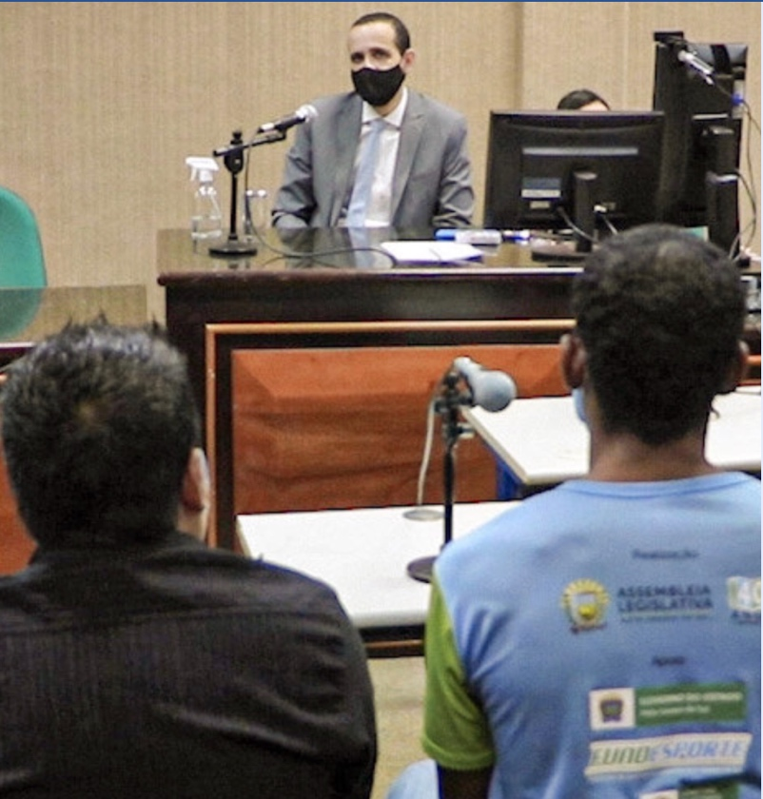
In Brazil, we continued to provide strategic support to the National Council of Justice and state courts on the critical role of judges to prevent torture. We also contributed to a manual on custody hearings for magistrates. In response to COVID-19, many courts across Brazil moved to hold custody hearings by video conference. With civil society, the APT strongly advocated for the resumption of face-to-face custody hearings to ensure judges can properly record and respond to allegations of torture.

Upholding justice in a pandemic
We produced a three-part video series to showcase COVID-safe adaptations by courts in nine Brazilian states and promote the importance of resuming face-to-face custody hearings throughout the country.

Watch the first video

Protecting persons in situations of vulnerability

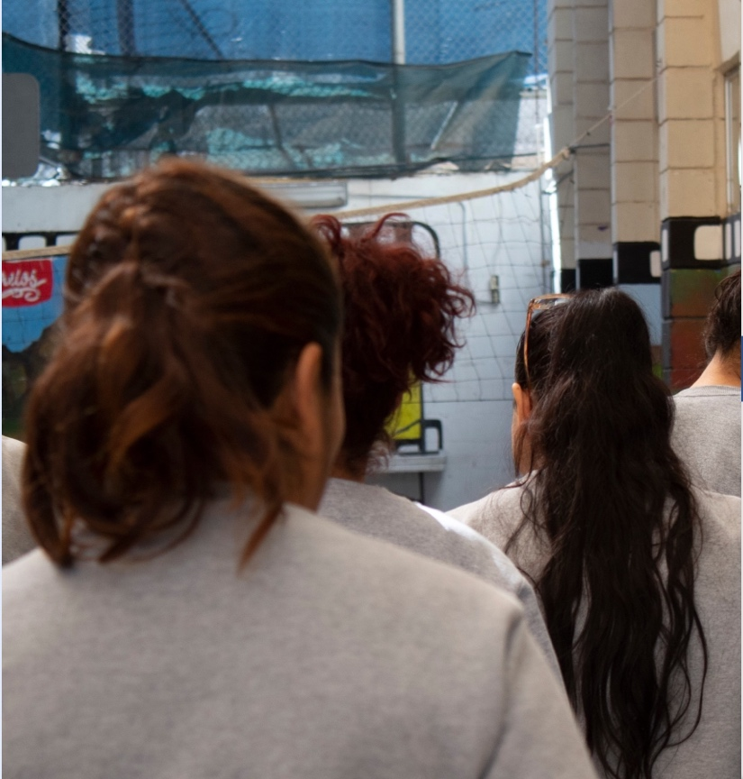
Everybody who is deprived of liberty is in a situation of vulnerability. However, some people – women, LGBTIQ people, asylum seekers and migrants – can face greater risks of abuse, mistreatment and violence in places of detention.

We work to increase attention on the specific needs of persons in situations of vulnerability and strengthen protection of their rights across the criminal justice system.

Our highlights in 2020

- In Brazil, we provided advice and support to a task force composed of representatives from the National Preventive Mechanism and civil society that is conducting thematic monitoring of LGBTIQ persons in detention.
- In a first, the APT worked with 16 National Preventive Mechanisms to prepare a joint submission for the Inter-American Court of Human Rights on practical measures to promote the safety and dignity of LGBTIQ persons in places of detention. This followed an open call for submissions on ‘Differentiated approaches to persons deprived of liberty’.
- In December, to mark the 10th anniversary of the UN Rules on the Treatment of Women Prisoners (Bangkok Rules), we launched a year-long campaign on women and prisons.

Making justice safer and fairer for women
Over the past ten years, the number of women imprisoned globally has grown by 50%. Many of these women have a history of victimisation, poverty, discrimination and mental health problems. Many are mothers or carers. For them, prison is not the right response.

Behind bars, women can face discrimination, violence and harassment. Trans women are especially vulnerable.

This is why we launched a year-long campaign on women and prison: to make justice safer and fairer for women.

Launched in December to mark the 10th anniversary of the UN Bangkok Rules, the campaign has the backing of National Preventive Mechanisms in more than 40 countries. We will mobilise and support them to drive lasting changes for women at the national level.

Our goal is to help create a world where there are alternatives to prison for women. And if detention is the only option, a world where prisons meet the needs of all women.

Watch the campaign launch video

“Thank you for this great initiative. We will be happy to incorporate APT's material in our reports.”
National Preventive Mechanism of Portugal

Communicating for change
Our communication seeks to mobilise, equip and support our partners, as well as engage with new audiences.

We visualise research and data to illuminate issues in new and creative ways. We record and share stories that document what torture prevention looks like and to inspire others.

And, during COVID-19, we ensured our partners could access the tools and resources they needed to assist them in their torture prevention work

Our highlights in 2020

- We launched our new website, featuring a comprehensive Knowledge Hub.
- With six partners, we established the Co:Lab Information Hub on COVID-19 and deprivation of liberty.
- We established with UNDP a digital mapping tool to assist decision makers within justice and detention systems in Latin America and the Caribbean.
- We showcased the work of independent oversight bodies during COVID-19 in our video series, Voices from the Field, and launched a new podcast, Perspectives.
- On International Day in Support of Victims of Torture – 26 June – we co-hosted a webinar with OHCHR on Combating torture in times of COVID-19: Testimonies from the ground.

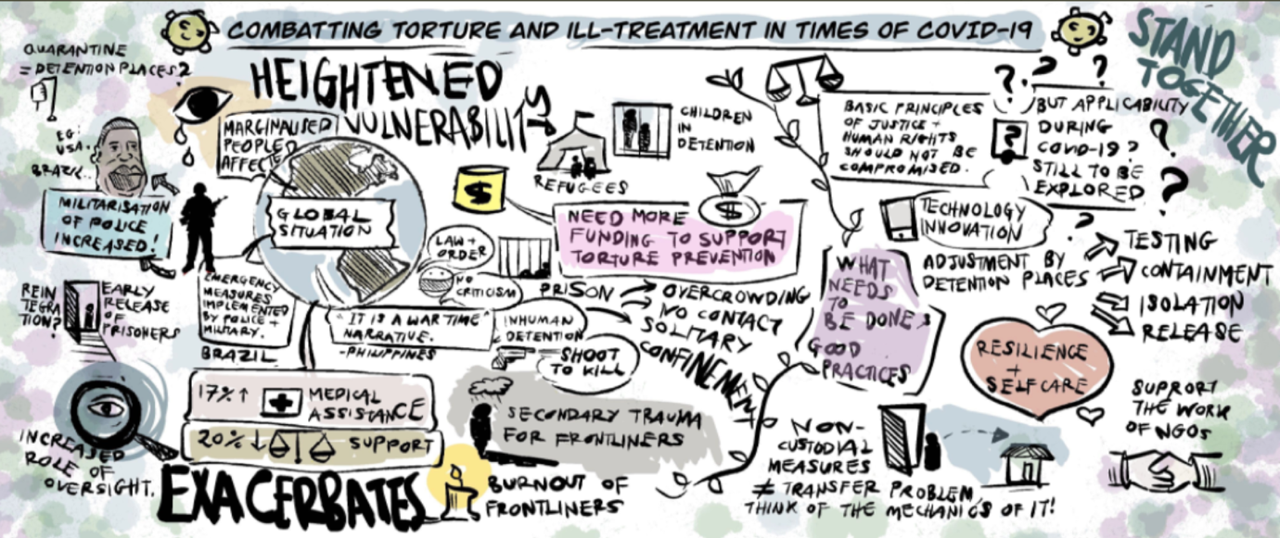
Shazeera Zawawi, APT

Courage during COVID
Voices from the Field is our new video series that documents the experiences of detention monitoring teams during COVID-19. We produced 13 videos in 2020 – available with English, French and Spanish subtitles – featuring oversight bodies from around the globe.

Amplifying new voices
In May, we launched a podcast – Perspectives – to share fresh insights on contemporary issues related to dignity in detention, including monitoring during COVID-19 and tackling systemic racism in law enforcement institutions.

Contributing to public debate
During the year, we published opinion pieces on issues at the centre of public conversation: the urgent to dismantle systemic racism in police institutions; the impact of COVID-19 on places of detention; the threat to democracy when peaceful protests are met with force, repression and torture; and, with national partners, on the need to reinstate face-to-face custody hearings during COVID-19 (for Le Monde Diplomatique Brasil).

Strengthening oversight of closed institutions

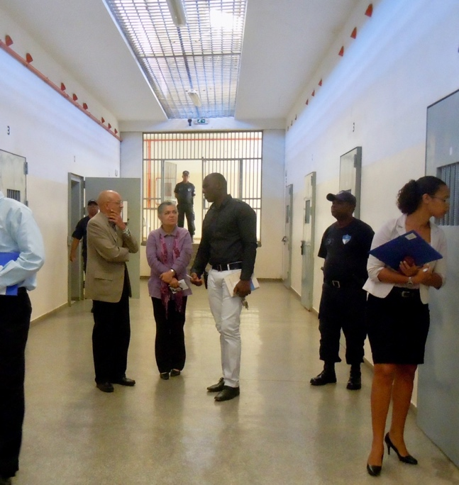
Anyone held in a closed facility – such as a prison, psychiatric institution or immigration detention centre – can be at risk of torture and ill-treatment. This is why transparency and monitoring are so crucial.

When the pandemic surged, the monitoring role of National Preventive Mechanisms (NPMs) and other oversight bodies was absolutely critical. Some continued regular visits, others moved to remote monitoring.

We helped them develop new ways of working by organising consultations, facilitating peer exchanges and providing expert advice.

Our highlights in 2020
- We published Practical Guidance on Monitoring Places of Detention During COVID-19, in partnership with OSCE-ODIHR.
- We launched an online platform for exchange for NPMs during COVID-19.
- We provided support and advice to 40 NPMs and national human rights institutions through bilateral training workshops and regional seminars.
- We advocated on behalf of Brazil’s NPM when it faced restrictions to its independence and operations.
- In cooperation with OHCHR, we organised the first-ever virtual ‘Meet & Greet’ with candidates for election to the UN Subcommittee on Prevention of Torture.

A long-term partnership for change in Rwanda
In November, we held a four-day workshop with members of Rwanda’s newly-designated NPM. The training included visits to police stations in Kigali to monitor the implementation of safeguards during the first hours of police custody.

This was the APT’s only in-country activity during COVID-19. We ensured all appropriate health and safety precautions were taken.

We conducted three virtual training sessions with the NPM team prior to the workshop, including an exchange of best practices from other NPMs around the world.

Rwanda’s NPM was officially established within the National Human Rights Commission in July 2020. However, our relationship with the Commission extends back to 2015, when we were invited to support national efforts to implement the Optional Protocol to the Convention against Torture in Rwanda.

We also conducted training with the Commission in 2018 and 2019 on organisational and planning issues to establish an NPM, as well as on detention monitoring practices.

Practical support for detention monitors
In June, we published a short video on the key principles to monitoring during COVID-19 to accompany our practical guidance for NPMs and oversight bodies.

Transforming our organisation

Two years ago, we embarked on a journey to transform our organisation and how we work with our partners.

We reflected on our vision and mission, as well as our difficult financial situation. We asked ourselves: is the way we work today the best way to achieve our goals and build partnerships to drive change?

As a team, we revisited how we work, considered different options and chose to make agility a central principle. We overhauled staff portfolios and increased the responsibilities of each team member, from administration and finances to programme work and leadership. We invested in digital technology and established new ways to collaborate.

We also had to take some very difficult decisions, including cutting posts and not filling vacancies.

The COVID-19 situation accelerated our transformation. We were able to respond quickly and effectively to the challenges posed by the pandemic and support our partners.

This process of transformation is only the beginning. We continue to reflect and adjust so we can be as effective as possible.
We are committed to staff well-being and living our values of collaboration and inclusiveness.

Audrey Olivier-Muralt
APT Deputy Secretary General

2020 in numbers

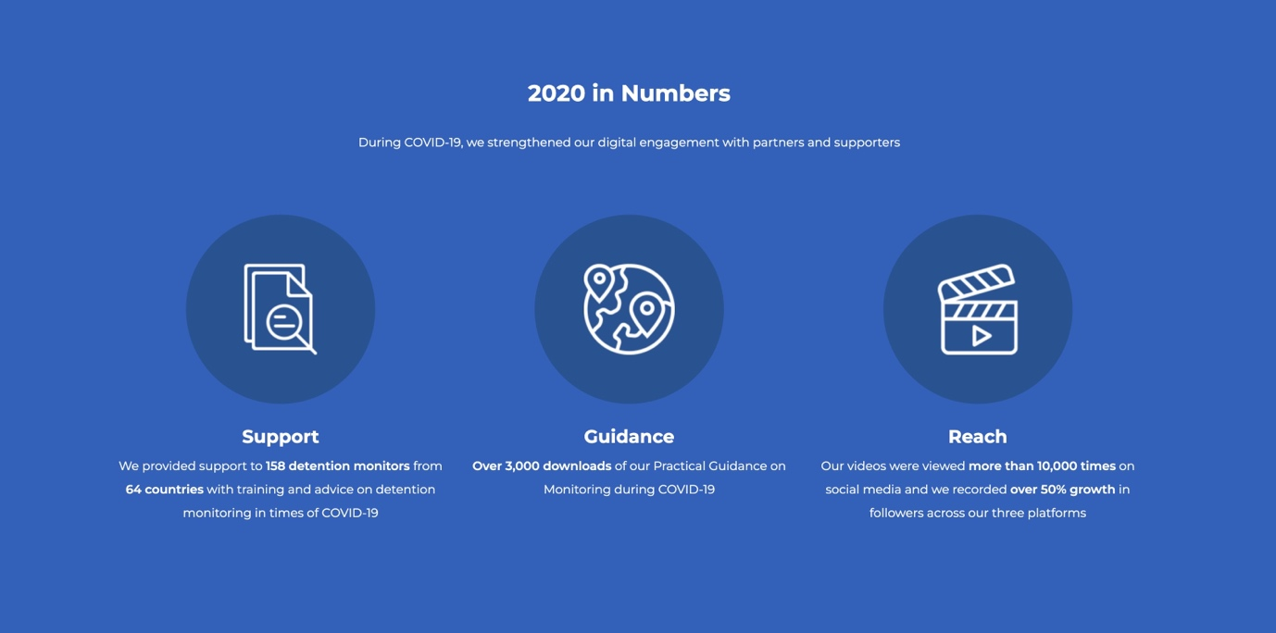

Our people

Board
President: Martine Brunschwig Graf (Switzerland)
Vice-Presidents: Michael Kellett (UK); Erika Schläppi (Switzerland)
Treasurer: Klaus Belzer (Switzerland)
Board members: Abdelwahad Hani (Tunisia), Cecilia Jimenez-Damary (Philippines), Krassimir Kanev (Bulgaria), Jacques Lederrey (Switzerland), Juan Mendez (Argentina), Merwat Rishmawi (Palestine/UK), Suzanne Soukoudé (Togo), Walter Suntinger (Austria)

In 2020, Jeehan Mahmood left the Board and joined our Advisory Board.

Staff
Sandra Andenmatten, Barbara Bernath, Benjamin Buckland, Alexis Comninos, Sylvia Dias, Catherine Felder, Veronica Filippeschi, Andra Nicolescu, Audrey Olivier-Muralt, Cecile Trochu Grasso, Shazeera Zawawi; supported by James Iliffe, Sara Vera López, Elena Maria Hernandez Martinez.

We also remember colleagues who left the APT in 2020: Jean-Sébastien Blanc, Eva Csergö, Rachel Delapierre, Yasmine Shams.

Finances, funding and support

We ended 2020 in a positive financial position. This was mainly due to a lower operating budget than in previous years, as we decreased expenditure in response to COVID-19 restrictions. Our smaller secretariat also meant we had lower fixed costs.
The APT is grateful for the flexibility of our donors as we made necessary adjustments to continue implementing our projects during the pandemic.

A significant proportion of core funding enabled us to respond swiftly and effectively to the needs of our partners at this time. It also supported us to commence our 2020-2023 Strategic Plan and continue our organisational transformation.

In 2020, we benefited from pro bono support provided by highly-qualified professionals in different fields. Their time and expertise helped improve our work around the globe.

We generated income through renting office space and fees for our advisory services on torture prevention.

Fundraising continues to be an institutional priority that should strengthen our financial stability in 2021 and onwards.

We are grateful for the support of all our donors and supporters. It allows us to stand for the dignity of people behind bars and those who work in places of detention.
Detailed financial statements are available here.

Thank you

We are grateful for the financial support of all our donors. Your donation allows us to stand for the dignity of people behind bars and those who work in places of detention.

We are also inspired by the individuals who provided high-level professional support to the APT in 2020. Thank you for giving us your time and expertise to improve our work around the globe.

