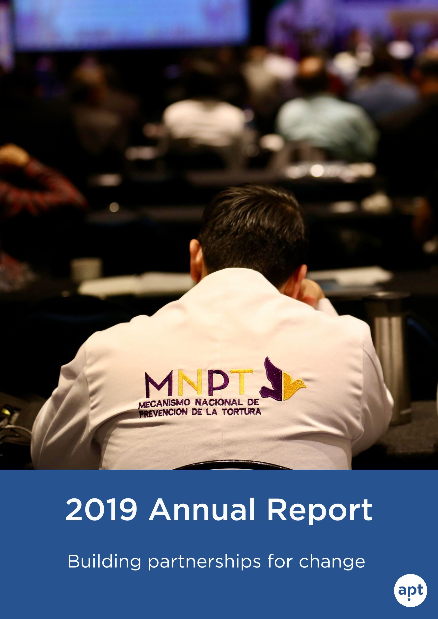

Message from our Secretary General

Prevention of torture made progress in 2019.

Around the world, 71 national bodies visit all types of places of detention. Thanks to our regional meetings in Africa, Americas and Europe they are stronger together.

There is a growing recognition of the need to move away from forced confessions and adopt other methods to collect reliable information and ensure justice.

Law enforcement, civil society and families better know the rights and safeguards applicable in the early hours of detention.

Last but not least, the most vulnerable in detention, in particular women and LGBTI persons, are not invisible anymore.
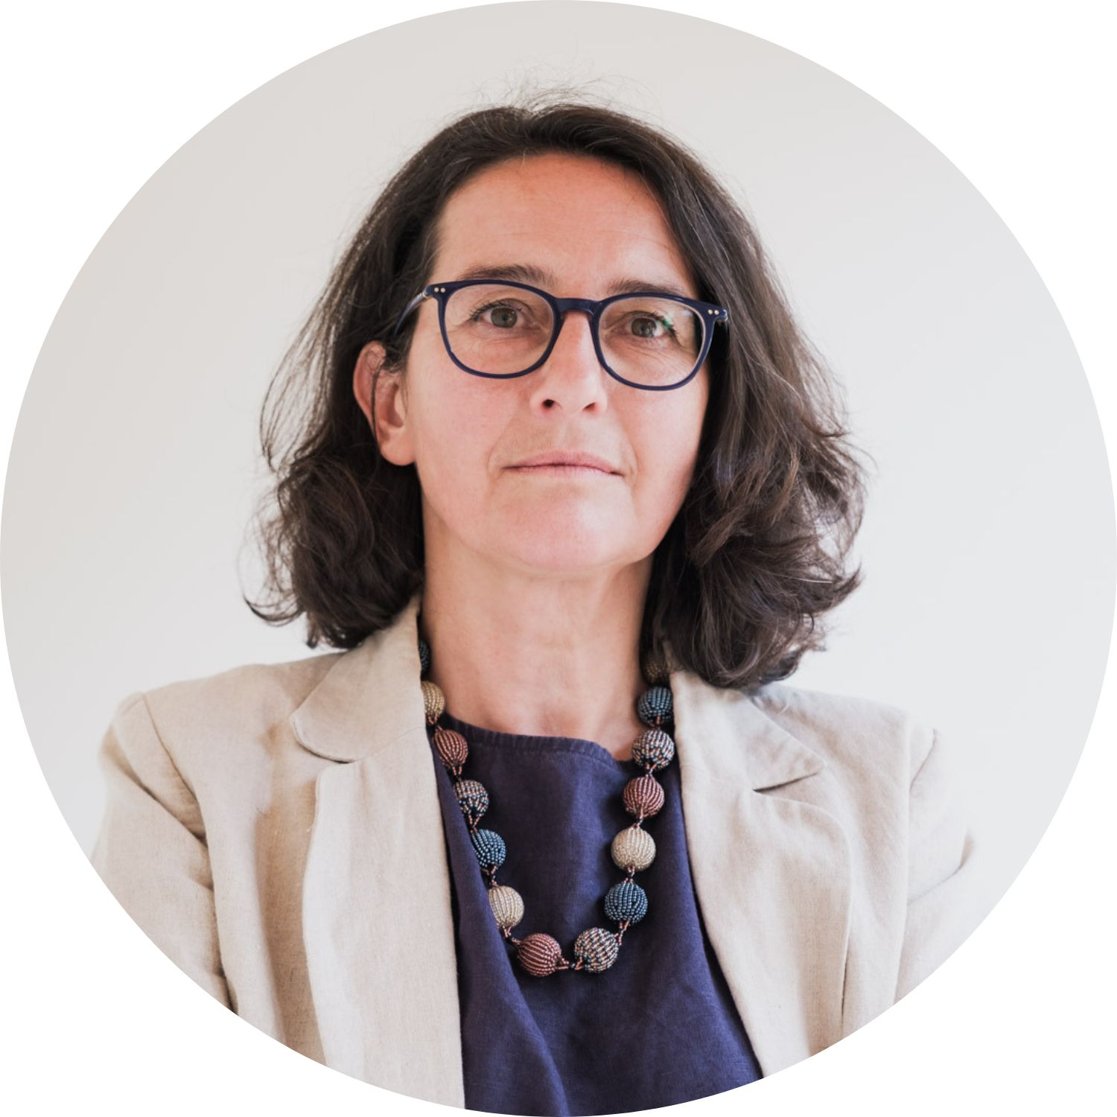
We thank our partners who made this possible.

Barbara Bernath
APT Secretary General

Video: 2019 in review

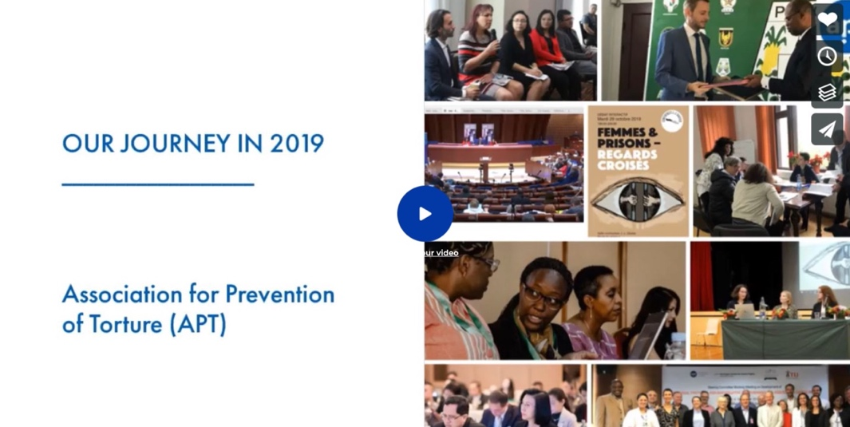

Discover our key achievements in 2019.

Last year, our work with partners across the globe helped increase independent oversight of detention, promoted the rights of detainees during the first hours of custody, and shed lights on persons in situation of vulnerability.

Celebrating 30 years of preventive monitoring in Europe

In 1989, the European Committee for the Prevention of Torture (CPT) was established under the Council of Europe, following advocacy of the APT (Swiss Committee against Torture at the time). Jean-Jacques Gautier’s vision of an independent detention monitoring body carrying out unannounced visits to all places of deprivation of liberty, was concretized.
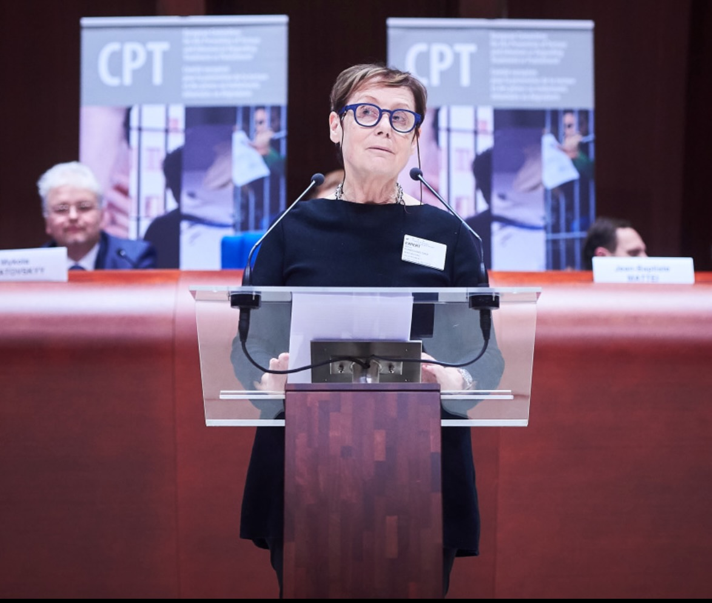

In November 2019, we gathered practitioners from all over Europe to discuss achieved progress, challenges and ways forward, with a focus on fundamental safeguards in police custody.

Guidelines on non-coercive interviewing
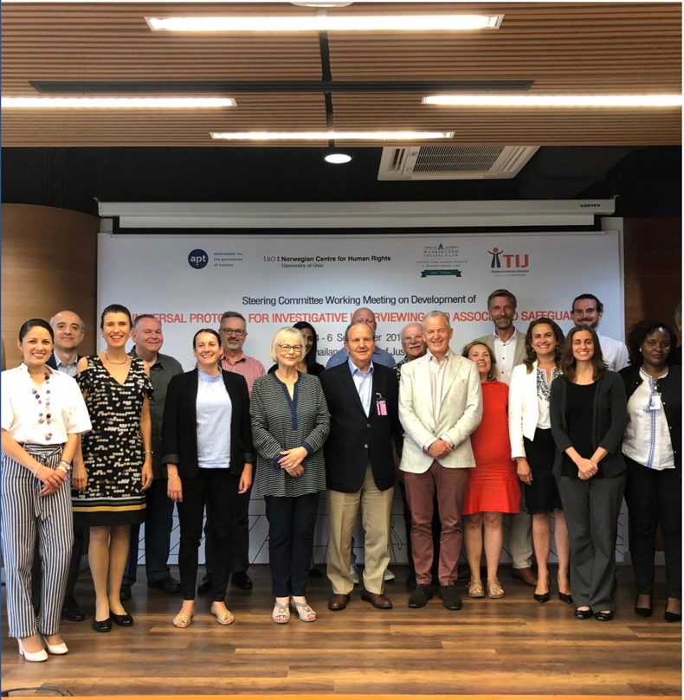
We continue to spearhead the development of the Guidelines, coordinating the work of the initiative’s expert-led bodies, participating in developing and implementing strategies for advocacy worldwide.

Milestones include two working meetings (Thailand and Norway) and significant progress on the draft; regional and international awareness-raising; new partnerships with national, regional, and international stakeholders; and recognition of the initiative by UN High Commissioner for Human Rights (in report) and the UN General Assembly (in resolution).

Emerging National Preventive Mechanisms in Africa
A core group of a dozen established NPMs has begun to work in Africa and can also assist each other as a regional community. The APT supported these efforts through regional workshops – one in Morocco for French-speaking bodies, and one in Rwanda. They brought together African NPMs to share their priorities, discuss challenges, and decide on ways they can work together in the future.

We have also continued our strategic support for the NPMs of Tunisia and Mauritania., and provided support for the newly established NPMs of Togo and Rwanda, including by providing detention monitoring trainings, guidance on internal organization within NHRI structures, and support for their first year strategic operations planning.

Progress made to reduce risks facing those most vulnerable in detention

Deprivation of liberty can be especially harmful for persons in situation of vulnerability, who have specific needs and require additional protection.

A roundtable on the topic of women in prison in Geneva saw fruitful discussions with experts and practitioners, and promoted the application of gender-sensitive perspective across the prison system.

We led discussions with experts, civil society, and NPMs on protection measures for LGBTI detainees in Panama and in Brazil, where we participated in a Congressional hearing on the same topic. In Romania, we trained the NPM in monitoring psychiatric institutions, laying the ground for increased cooperation with authorities.

Implementing concrete safeguards in the first hours of detention

Access to a lawyer, immediate information of the family about the arrest or registration of detention are key to reduce the risk of torture and ill-treatment in the first hours of detention. In 2019, we assisted our partners in making these rights better known and better implemented in practice.
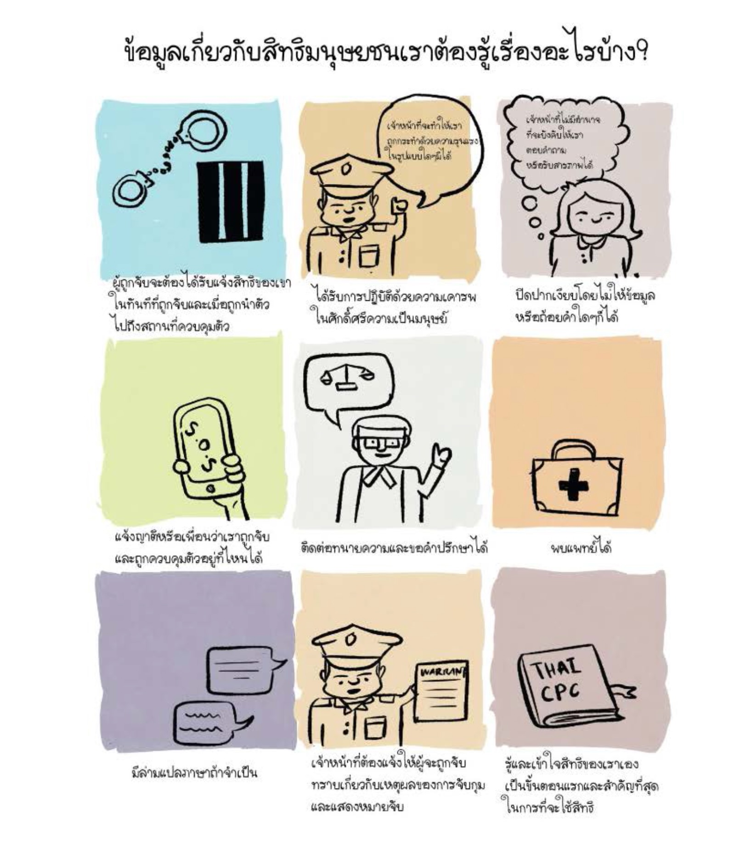

In Thailand, the APT developed an Action Toolkit to disseminate information about rights and notification of family among authorities and Thai public.

In Madagascar, we piloted the project in the four main police stations of the capital, testing new custody registers and a Letter of rights (read and handed over to each arrested person).

In Lebanon, we trained lawyers on their role in preventing torture and ill-treatment. In Morocco, together with the Centre on Human Rights and Democracy, we analysed and discussed the domestic challenges and good practices on implementing fundamental safeguards.

APT in numbers

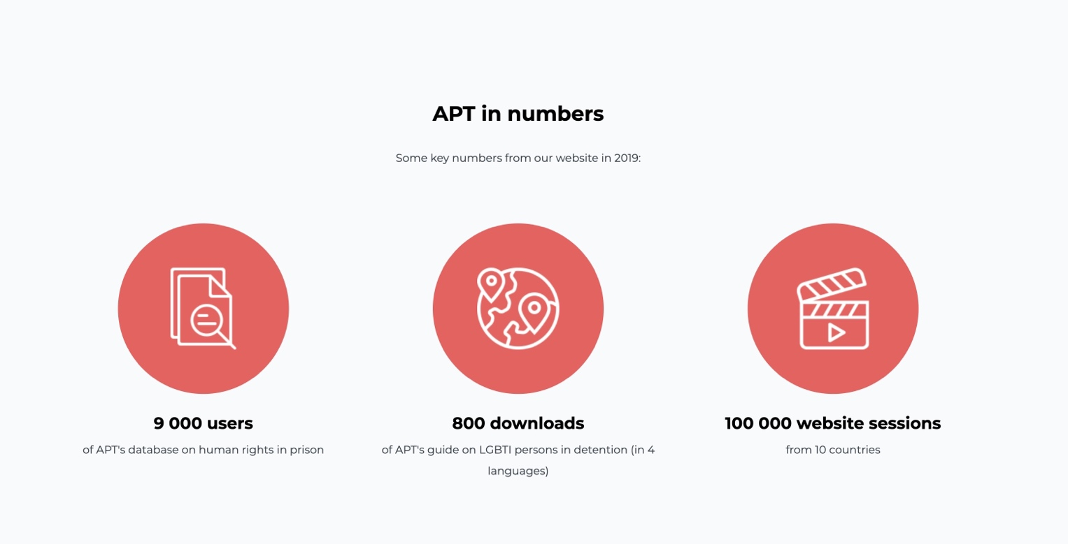
Latin America: enhancing the role of prevention mechanisms to monitor safeguards
National and Local Preventive Mechanisms play a key role in addressing the risks of torture during the early stages of detention and in monitoring the implementation of safeguards.

During the regional workshop organised by the APT and the Mexican NPM, exchanges showed that torture prevention mechanisms become more strategic in how they monitor the first hours of detention, focusing on situations of risks, including public protests. Some also developed tools to inform the public about their rights.

In Mexico and Paraguay, we facilitated dialogue with state institutions and authorities, and civil society, with the aim of advancing the safeguards implementation in practice.

Our finances

In 2019, there was a slight decrease in revenues, confirming the reorientation of some donors' priorities initiated in previous years.

This decline was limited mainly thanks to the trust of the Swiss Government, which increased its core support. In addition, we developed strategies to generate private donations and to diversify sources of income.

Efforts to reduce fixed costs were maintained with revision of service contracts. Several changes in the secretariat also resulted in a smaller team at the end of the year.

We are now in a transformative process to ensure greater financial stability. We thank our donors for their support and look forward to your renewed support.

More information is available in our audited financial statements.

Our people

APT Board
President: Martine Brunschwig Graf, Switzerland
Vice-Presidents: Michael Kellett (UK); Erika Schläppi (Switzerland).
Treasurer: Klaus Belzer (Switzerland).
Board members: Abdelwahad Hani (Tunisia), Cecilia Jimenez-Damary (Philippines), Krassimir Kanev (Bulgaria), Jacques Lederrey (Switzerland), Jeehan Mahmood (Maldives), Juan Mendez (Argentina), Merwat Rishmawi (Palestine/UK), Suzanne Soukoudé (Togo), Walter Suninger (Austria)

APT staff
Barbara Bernath, Sandra Andenmatten, Jean-Sébastien Blanc, Benjamin Buckland,
Eva Csergö, Alexis Comninos, Rachel Delapierre, Sylvia Dias, Catherine Felder,
Veronica Filippeschi, Isabelle Heyer Frigo, Anne Lardy, Sean Mowbray, Andra Nicolescu,
Jean-Baptiste Niyizurugero, Audrey Olivier-Muralt, Yasmine Shams, Cecile Trochu Grasso, Romain Zappella, Shazeera Zawawi

